Reto Semestral Ronda #1

Layla Tame

A01192934

**EASY – Left Rotate**

//

// main.cpp

// problem1

//

// Created by Layla Tame on 2/5/19.

// Copyright © 2019 Layla Tame. All rights reserved.

//

#include <iostream>

#include <vector>

using namespace std;

//Left Rotation - Easy

int main() {

int iN, iD;

cin >> iN >> iD;

int arr[iN], temp[iD];

for (int i = 0; i < iD; i++){

cin >> temp[i];

}

for (int i = 0; i<iN-iD; i++){

cin >> arr[i];

}

for (int i = iN-iD, k=0; i<iN; i++, k++){

arr[i] = temp[k];

}

for (int i = 0; i<iN; i++){

cout << arr[i];

if (i<iN-1)

{

cout << " ";

}

}

}

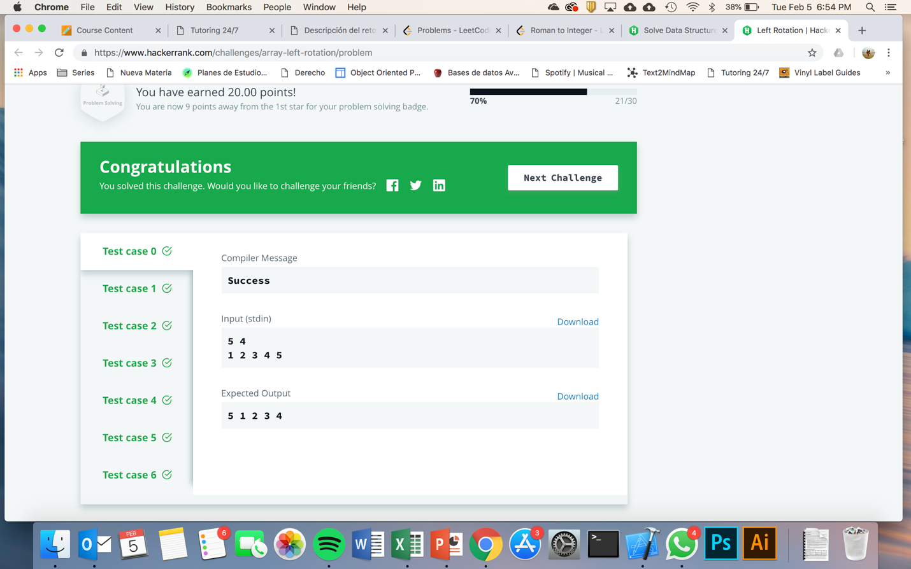

**MEDIUM – Sparse Arrays**

//

// main.cpp

// problem2

//

// Created by Layla Tame on 2/5/19.

// Copyright © 2019 Layla Tame. All rights reserved.

//

#include <vector>

#include <iostream>

using namespace std;

// Complete the matchingStrings function below.

vector<int> matchingStrings(vector<string> strings, vector<string> queries, int queries_count, int strings_count) {

vector<int> res(queries_count);

for (int i = 0; i < queries_count; i++){

int iCount = 0;

for (int j = 0; j < strings_count; j++){

if (queries[i] == strings[j]){

iCount++;

}

}

res[i] = iCount;

}

return res;

}

int main()

{

int strings_count;

cin >> strings_count;

vector<string> strings(strings_count);

string strings_item;

for (int i = 0; i < strings_count; i++) {

cin >> strings_item;

strings[i] = strings_item;

}

int queries_count;

cin >> queries_count;

vector<string> queries(queries_count);

string queries_item;

for (int i = 0; i < queries_count; i++) {

cin >> queries_item;

queries[i] = queries_item;

}

vector<int> res = matchingStrings(strings, queries, queries_count, strings_count);

for (int i = 0; i < res.size(); i++) {

cout << res[i];

if (i != res.size() - 1) {

cout << "\n";

}

}

cout << "\n";

return 0;

}

